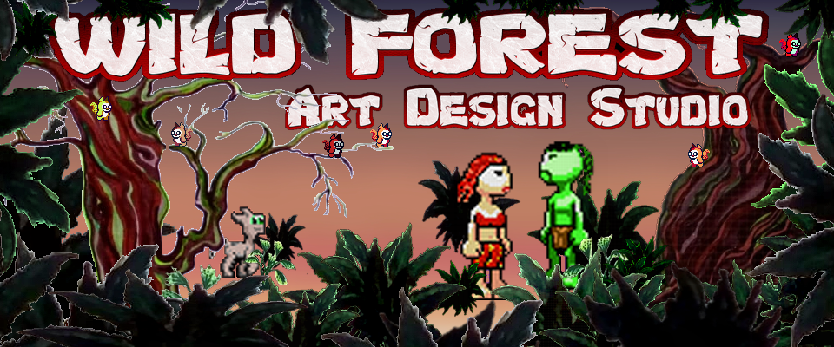
Wild Forest
Art design studio
Video games,and game assets https://wild-forest.itch.io/
also we do paintings,wood carving,juvelry etc.
we are on our way to create some nice and fun games,suport us with nice word,sugestion,share are page,or cooperate on some project :)
our main goal are retro local multiplayer games but hope leter we go for some biger projects.
for begining we do plane and are working on few multiplayer games ,a top down racing game, a platformer,puzzle and top down game.
we will see how its gonna go :) stay with us, lets create new worlds together :D

